COM668 Computing Project
Assessment Task 2 – Challenge Definition Report

Project title: Smart Pet Care & Monitoring Ecosystem
Student name: Abbas Uddin
Student ID number: B00965263
PSG identifier: PSG-Q20
Mentor name: Tendai Mhlanga
Course title: BSc (Hons) Computing Systems
Year of submission: 2025/2026
Word Count (3600 Maximum): 3506

I declare that this is all my own work. Any material I have referred to has been accurately referenced, and any contribution of Artificial Intelligence technology has been fully acknowledged. I understand the importance of academic integrity and have read and understood the University’s General Regulation: Student Academic Integrity and the Academic Misconduct Procedure. I understand that I must not upload my work before, during or after submission to any unapproved plagiarism detectors or answer-sharing platforms, or equivalent, and that only University-approved platforms should be used.
AI Acknowledgement Statement: In accordance with the above declaration, I formally acknowledge the use of Generative AI (Claude Opus 4.7 and Google Gemini) strictly as an editorial and proofreading assistant. All system architectures, database schemas, UI/UX designs, and engineering paradigms presented herein are my original intellectual property. AI tools were utilised solely to structure these original concepts into formal Level 6 academic prose and to ensure Harvard citation compliance. All AI outputs were independently audited against primary technical documentation to ensure accuracy.

1. Problem definition 1
1.1 Aim 1
1.2 Problem description 1
1.3 Scope 2
1.4 Intended outcome 2
1.5 Objectives 3
2. Contextual research 3
2.1 Context investigation 3
2.2 Supporting theory research 3
2.3 Similar products review 4
3. Software definition 5
3.1 Requirements analysis 6
3.2 Risk analysis 6
3.3 Design (system and data design) 7
3.4 User experience design 8
4. Planning 9
4.1 Methodology 9
4.2 Initial plans 10
References 11

1. Problem definition

1.1 Aim
This project aims to design, implement, and develop a critical, distributed four-tier microservice to unify real-time edge-based behavioural inference, longitudinal metabolic analytics, and cryptographically authorised veterinary record sharing within a GDPR-aligned single platform. In that way, it will close the gap between domestic companion-animal observation and professional veterinary intervention while demonstrating undergraduate-level mastery of modern full-stack, Edge AI, and secure API engineering practices.

1.2 Problem description
Companion-animal welfare in the United Kingdom suffers from three empirically documented deficiencies that current consumer products address only in isolation. First, canine obesity affects approximately 34–59% of domestic dogs (German, 2006), a figure that remains critical as recent data indicates that while nearly half of UK dogs are clinically overweight, only 4% of owners accurately recognise this condition (UK Pet Food, 2024). This systemic underdiagnosis stems from the absence of continuous inter-visit weight trajectory tracking, resulting in preventable metabolic morbidity. Second, separation-related disorders manifest in an estimated 22–55% of dogs, yet their detection depends on owner observation, which is logically unavailable precisely when the animal is alone and symptomatic (Sargisson, 2014). Third, during acute emergencies, owners rarely carry consolidated medical documentation, compelling emergency practitioners to treat without verified history and demonstrably prolonging time-to-diagnosis. Commercial incumbents are strictly partial in their remit: Whistle provides activity telemetry, Furbo delivers cloud-dependent video streaming, and PetDesk centralises appointment administration. None fuses continuous Edge AI behavioural inference, server-side metabolic forecasting, and a portable, time-expiring Electronic Health Record (EHR) into a single, architecturally coherent, data-minimised platform. The engineering challenge is therefore the synthesis, not the invention, of these discrete capabilities into a single secure, responsive, and ethically defensible distributed system.

1.3 Scope
The scope is delimited to a functional prototype comprising four interoperating services: a Laravel 13 headless RESTful API backed by a normalised, UUID-keyed MySQL schema; a Next.js (App Router, v16+) veterinarian portal styled with Tailwind CSS v4+ under a CSS-first configuration; a React Native owner application targeted for Android and iOS; and a Python edge service utilising OpenCV and a YOLO26n model exported to ONNX or OpenVINO for CPU-class inference. Included are authentication via Laravel Sanctum, Firebase Cloud Messaging push notifications, Mapbox-based triage routing, JWT-governed EHR exchange, and asynchronous processing through Laravel Queues. Explicitly excluded are bespoke hardware sensor manufacture, third-party live veterinary telemedicine integration, advanced 3D pose estimation, live commercial retail API integrations (substituted by a static mocked JSON dataset), and any production deployment beyond a supervised academic evaluation environment.

1.4 Intended outcome
The intended outcome is a demonstrable, end-to-end prototype that: (a) produces real-time behavioural alerts delivered to the owner application within a target webhook-to-push-notification latency of under five seconds; (b) renders veterinarian-facing metabolic trajectory visualisations populated from server-calculated BMI and BMR values; (c) issues, validates, and expires JWT-bound EHR access tokens without persisting plaintext credentials in transit or at rest; and (d) evidences BCS-aligned engineering rigour through version-controlled source code, systematic unit and integration tests, and a critically reflective AT4 Project Review Report. The artefact must also verifiably uphold GDPR Article 5 principles of data minimisation, purpose limitation, and storage limitation throughout. Evaluative telemetry—endpoint response times, inference frame rates, and end-to-end alert delivery latencies—will be captured, logged, and analysed throughout the evaluation period to substantiate these claims.

1.5 Objectives
The following SMART objectives direct the work and define its measurable success criteria. (i) Design and deploy a normalised MySQL schema spanning six UUID-keyed entities and expose Sanctum-authenticated RESTful endpoints, achieving at least 80% PHPUnit coverage of controller logic. (ii) Construct a Next.js veterinarian dashboard rendered predominantly via React Server Components, visualising weight and BMI trajectories with client-side interactivity isolated to discrete chart components. (iii) Implement a React Native owner application capable of receiving Firebase Cloud Messaging payloads and executing Mapbox-mediated geospatial routing to emergency clinics filtered by the is_emergency_24_7 predicate. (iv) Develop a Python edge service performing YOLOv8n inference at no fewer than 15 frames per second on an Intel Iris Xe CPU, applying Zone-Based Logic to emit asynchronous webhooks on threshold breach. (v) Critically evaluate the integrated artefact against BCS accreditation criteria, GDPR Article 5 minimisation principles, and the full set of defined functional and non-functional requirements.

2. Contextual research

2.1 Context investigation
The Smart Pet Care & Monitoring Ecosystem intersects two actively evolving research frontiers: resource-constrained Edge AI for continuous non-human subject observation, and cryptographically bounded access control for distributed Electronic Health Records (EHR). Neither domain is individually novel, yet their convergence within a single GDPR-aligned veterinary platform remains unaddressed in both the peer-reviewed literature and the commercial product landscape surveyed during AT1. A focused review of recent scholarship is therefore necessary to justify the chosen architectural posture, specifically, a locally inferenced Python perception service feeding an asynchronous Laravel API, fronted by a Next.js veterinarian portal and a React Native owner client as the defensible synthesis of otherwise partial precedents. The review below proceeds thematically, examining first the perception layer and then the secure data-exchange layer.

2.2 Supporting theory research
The viability of performing continuous, real-time behavioural inference on commodity hardware, rather than offloading raw frames to a remote inference endpoint, is now substantially established in the computer vision literature. Chappidi and Sundaram (2024) present a cascaded YOLOv8 framework augmented with adaptive preprocessing, demonstrating that edge-deployable variants of the YOLO family can sustain reliable animal feature extraction under variable illumination and occlusion conditions without recourse to server-side acceleration. This finding is directly applicable to the proposed Python microservice, which must classify companion-animal presence and posture from a domestic video stream on an Intel Iris Xe-class processor without a dedicated GPU. Rahman, Giordano and Pagano (2025) extend this argument by empirically evaluating lightweight deep neural networks on Jetson Nano and Raspberry Pi targets, concluding that local inference materially reduces both redundant data transmission and cumulative network load whilst mitigating the thermal throttling that is observed when sustained workloads are pushed to cloud endpoints over unreliable domestic connections. Their evidence supplies the theoretical warrant for exporting YOLO26n—the current lightweight variant in the Ultralytics YOLO lineage succeeding the YOLOv8 family evaluated by the foregoing authors—to ONNX or OpenVINO in the present architecture: the compression not only preserves inferential accuracy but also decouples behavioural latency from the end user's broadband quality, a non-trivial constraint when the system is specified to deliver anxiety alerts within a five-second end-to-end budget.
Complementary to the perception layer, the secure distribution of medical records under time-bounded authorisation constitutes the second theoretical pillar of the proposed system. Purnama and Sudewa (2026) formalise a decentralised EMR framework in which fine-grained access is enforced by JSON Web Tokens (JWTs) carrying explicit expiry claims, validating a fifteen-minute read-only window for external medical personnel. Their work reframes access control as a cryptographic, rather than a session-state, concern — a distinction of practical importance in emergency veterinary contexts, where an owner may need to grant an unknown practitioner immediate read access to a patient's history without establishing a persistent account relationship. The short-lived-token pattern also satisfies GDPR Article 5(c) data minimisation and Article 5(e) storage limitation obligations, as authorisation self-expires and cannot be replayed beyond its validity window. This theoretical foundation directly informs the Portable EHR Wallet design: the Laravel backend will issue a hashed, expiry-bound JWT for each disclosure event, the plaintext token is transmitted once through a distribution channel of the owner's choosing, and the Next.js portal decodes it server-side before rendering the record. No long-lived veterinary credential persists against what is fundamentally a transient clinical encounter, materially narrowing the residual attack surface.

2.3 Similar products review
Although the theoretical foundations above are established in isolation, Chamorro and Benítez (2025) provide the closest integrated architectural precedent to the present work. Their Animal Tracking System for intrusion detection in human settlements couples a YOLO-based perception layer with a decoupled React frontend communicating through a dedicated backend API, generating real-time alerts when a tracked subject crosses a defined spatial boundary. Three architectural correspondences merit explicit recognition. First, their use of a YOLO variant for continuous localisation of a non-human subject directly mirrors the proposed Zone-Based Logic employed here, where the lightweight YOLO26n model is utilised to infer separation anxiety via "Time-in-Zone" heuristics rather than computationally expensive three-dimensional pose estimation. Second, the physical decoupling between the inference runtime and the presentation layer academically legitimises the asynchronous webhook strategy, in which the Python microservice dispatches HTTP POST payloads to the Laravel API, allowing the video feed to continue uninterrupted while the backend enqueues the event for later processing. Third, their React-based consumer interface anticipates the dual-frontend model adopted here, in which a Next.js veterinarian portal and a React Native owner client consume a common JSON contract exposed over Sanctum-authenticated endpoints.
In parallel, Rajesh et al. (2025) offer the clearest healthcare-domain analogue for the chosen backend and web tier. Their Smart, Secure and Scalable Cloud-Based Healthcare System pairs a React frontend with a token-secured backend API, combining JWT issuance with strict Role-Based Access Control to govern multi-actor EHR workflows. Two elements transfer directly to the present design. Principally, their demonstrated coupling of JWT authorisation with RBAC validates the architectural decision to enforce role boundaries — owner, vet, administrator — at the Laravel Sanctum layer, with Next.js 16+ App Router components consuming pre-authorised, role-scoped JSON payloads predominantly through React Server Components. Additionally, their evidence that a React-oriented frontend can sustainably mediate sensitive clinical data under token-governed access substantiates the proposed migration away from the commercial incumbents whose architectural postures are strictly partial: Whistle addresses only activity telemetry, Furbo only cloud-dependent streaming, and PetDesk only appointment administration. The synthesis proposed here — unified Edge AI behavioural inference, server-side metabolic forecasting, and cryptographically bounded EHR exchange within a single ecosystem — is therefore academically grounded in, yet demonstrably distinct from, the surveyed literature and the commercial state of the art.

3. Software definition

3.1 Requirements analysis
Requirements were elicited from the architectural brief and the literature synthesised in Section 2, and are prioritised under the MoSCoW scheme. Must functional requirements include: Sanctum-authenticated registration and login supporting 'owner', 'vet', and 'admin' roles (FR-01); owner-driven pet profile creation capturing species, breed, and date of birth (FR-02); server-side BMI and BMR computation from weight submissions (FR-03); asynchronous webhook ingestion from the Python perception service (FR-04); issuance of a hashed, time-expiring EHR JWT (FR-05); JWT decoding and record rendering within the Next.js portal (FR-06); Firebase Cloud Messaging delivery to the React Native client upon behavioural event logging (FR-07); and Mapbox-mediated triage routing filtered by the is_emergency_24_7 predicate (FR-08). The veterinarian weight-trajectory dashboard is designated Should (FR-09); the Pet Food Locator backed by a mocked dataset is Could (FR-10). Live commercial retail integration, three-dimensional pose estimation, and production cloud deployment remain classified as Won't within this iteration.
Non-functional requirements operationalise the success criteria declared in Section 1.4. NFR-PERF-01 bounds end-to-end behavioural alert latency — measured from webhook dispatch to push receipt — at fewer than five seconds at the 95th percentile. NFR-PERF-02 requires sustained YOLO26n throughput of no fewer than fifteen frames per second(targeting the documented ~25 FPS CPU ONNX baseline) on an Intel Iris Xe CPU following ONNX or OpenVINO export, consistent with Rahman, Giordano and Pagano (2025). NFR-PERF-03 caps Laravel API P95 response time at 500 milliseconds for non-cryptographic endpoints. NFR-SEC-01 fixes the EHR JWT validity window at fifteen minutes, adopting the parameter empirically validated by Purnama and Sudewa (2026). NFR-SEC-02 mandates UUID v4 primary keys and Argon2id password hashing. NFR-AVAIL-01 targets 99.5% EHR portal availability during the evaluation window. NFR-COMP-01 enforces GDPR Article 5(c) data minimisation and Article 5(e) storage limitation across all processing pipelines.

3.2 Risk analysis
Three technical risks exhibit sufficient combined likelihood and impact to warrant explicit mitigation within the implementation plan.
R-01: Perception-layer thermal throttling (Likelihood: High; Impact: High). Sustained YOLO26n inference on the Intel Iris Xe target is expected to induce thermal throttling, degrading frame rate below NFR-PERF-02 and invalidating the real-time claim. Mitigation is layered: export of model weights to ONNX or OpenVINO to exploit Intel-specific acceleration paths; deterministic frame skipping at capture time to cap workload irrespective of source rate; and an adaptive watchdog that reduces input resolution when sustained CPU package temperature exceeds a calibrated threshold.
R-02: Mobile connectivity failure during emergency routing (Likelihood: Medium; Impact: High, given the safety-critical context). The React Native client is vulnerable to network degradation or full connectivity loss mid-route. Mitigation involves client-side caching of the most recently retrieved 24/7 clinic list with a signed timestamp, a geolocation-only fallback that displays clinic markers without turn-by-turn polyline rendering when Mapbox tile retrieval fails, and an optimistic UI pattern that surfaces cached results immediately while asynchronously revalidating against the API.
R-03: Database deadlock under concurrent webhook bursts (Likelihood: Medium; Impact: Medium). Concurrent inserts into behavioral_events from a misbehaving perception loop may contend for identically indexed rows. Mitigation dispatches all webhook processing to Laravel Queues so the HTTP handler returns 200 OK immediately, tunes transactional isolation to READ COMMITTED for the event-insertion path, and applies an idempotency key derived from the perception service's event UUID to render retried dispatches non-destructive.

3.3 Design (system and data design)
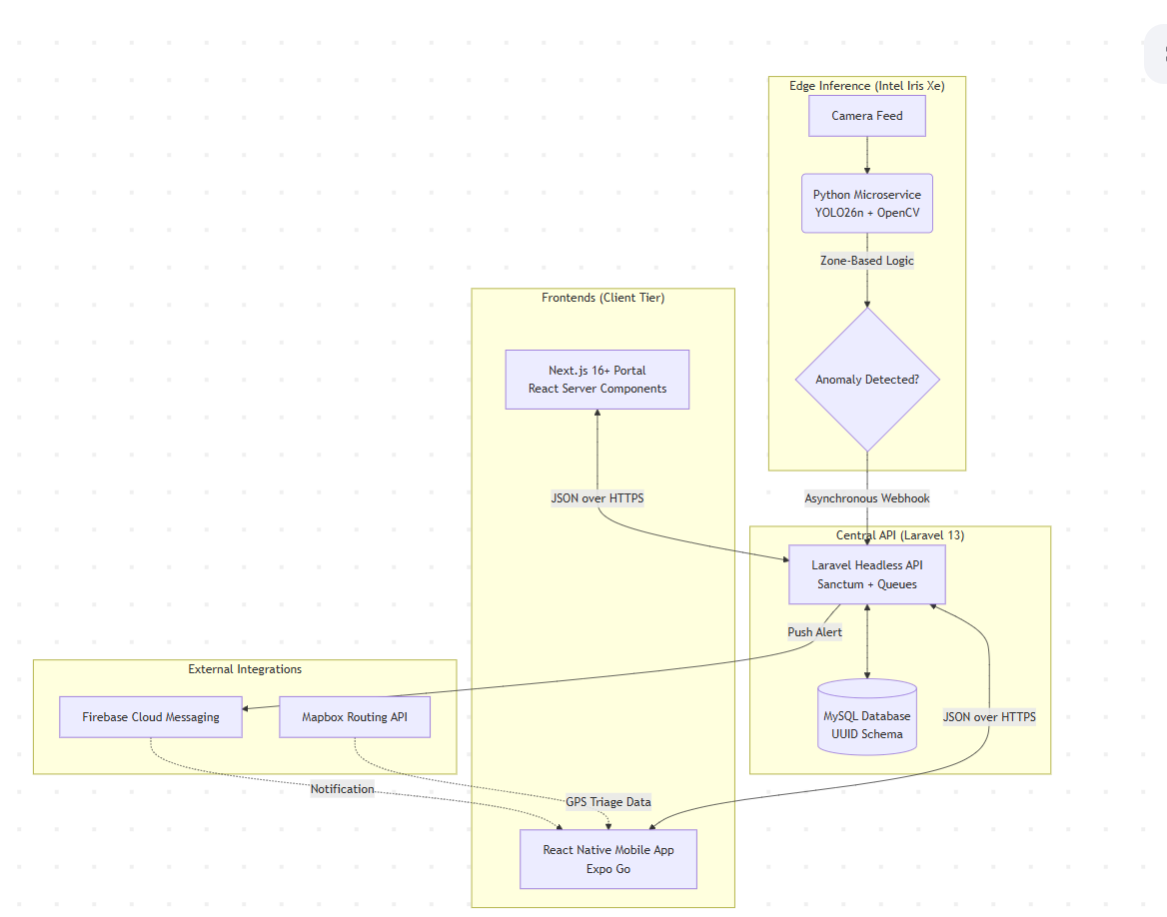
Figure 1: High-Level System Architecture and Microservice Integration.
The backend is implemented as a headless, resource-oriented RESTful API exposed under a versioned /api/v1/ namespace, returning JSON payloads within a consistent envelope (data, meta, errors). Authentication is enforced through Laravel Sanctum: the Next.js portal operates under stateful cookie authentication with CSRF protection, whilst the React Native client authenticates via bearer tokens bound to per-device abilities. Each resource is guarded by Laravel Policy classes enforcing Role-Based Access Control in line with the pattern validated by Rajesh et al. (2025). Heavy workloads — EHR PDF generation, metabolic trajectory recalculation, and Firebase fan-out — are delegated to Laravel Queues so that request handlers remain non-blocking and satisfy NFR-PERF-03.
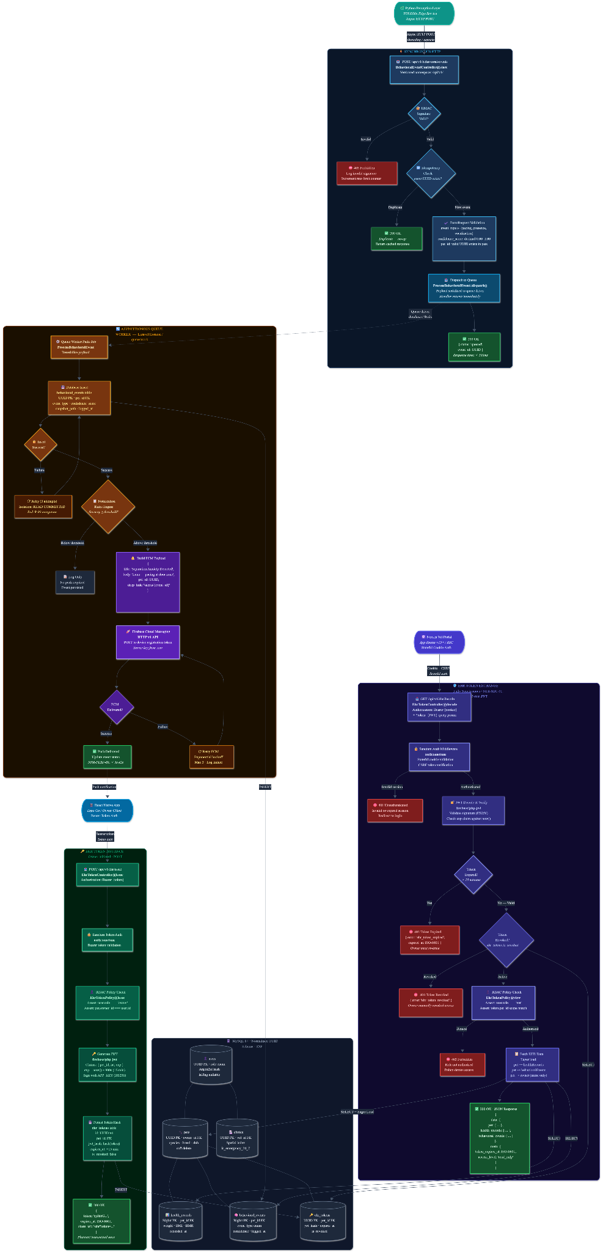
The relational schema is normalised to third normal form and comprises six entities drawn directly from the architectural brief: users (core identity, role-scoped via an enumerated column); clinics (geospatially indexed, one-to-one with a vet user); pets (1:M under users, soft-deletable via a nullable deleted_at column); health_records (1:M under pets, capturing weight and server-calculated BMI and BMR); behavioral_events (1:M under pets, populated by the perception layer); and ehr_tokens (1:M under pets, holding the hashed JWT and its expires_at timestamp). Referential integrity is enforced at the database level via foreign-key constraints with explicit ON DELETE semantics, and the geospatial columns on clinics are spatially indexed to service proximity queries efficiently.
All primary keys are Universally Unique Identifiers (UUID v4) rather than auto-incrementing integers, a decision justified on three grounds. First, UUIDs eliminate the sequential predictability that enables ID enumeration attacks: an adversary cannot infer /api/v1/pets/124 from a legitimately observed /api/v1/pets/123. Second, UUIDs disclose no cardinality information; the volume of registered users, pets, or issued EHR tokens cannot be inferred from any individual identifier. Third, UUIDs support decentralised generation across distributed services, permitting the Python perception microservice to assign identifiers to behavioral_events prior to webhook dispatch without a synchronous round-trip to the database authority, materially contributing to NFR-PERF-01.
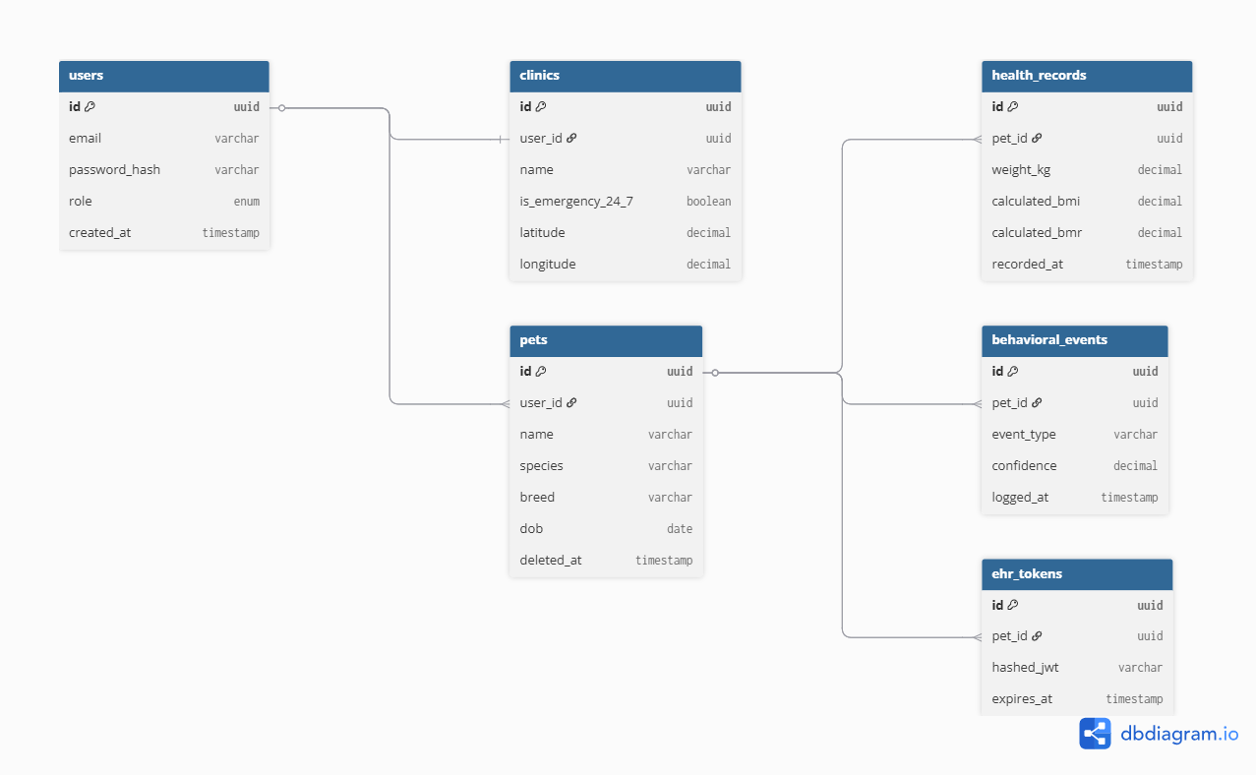
Figure 2: Entity-Relationship Diagram detailing the UUID-keyed MySQL schema.
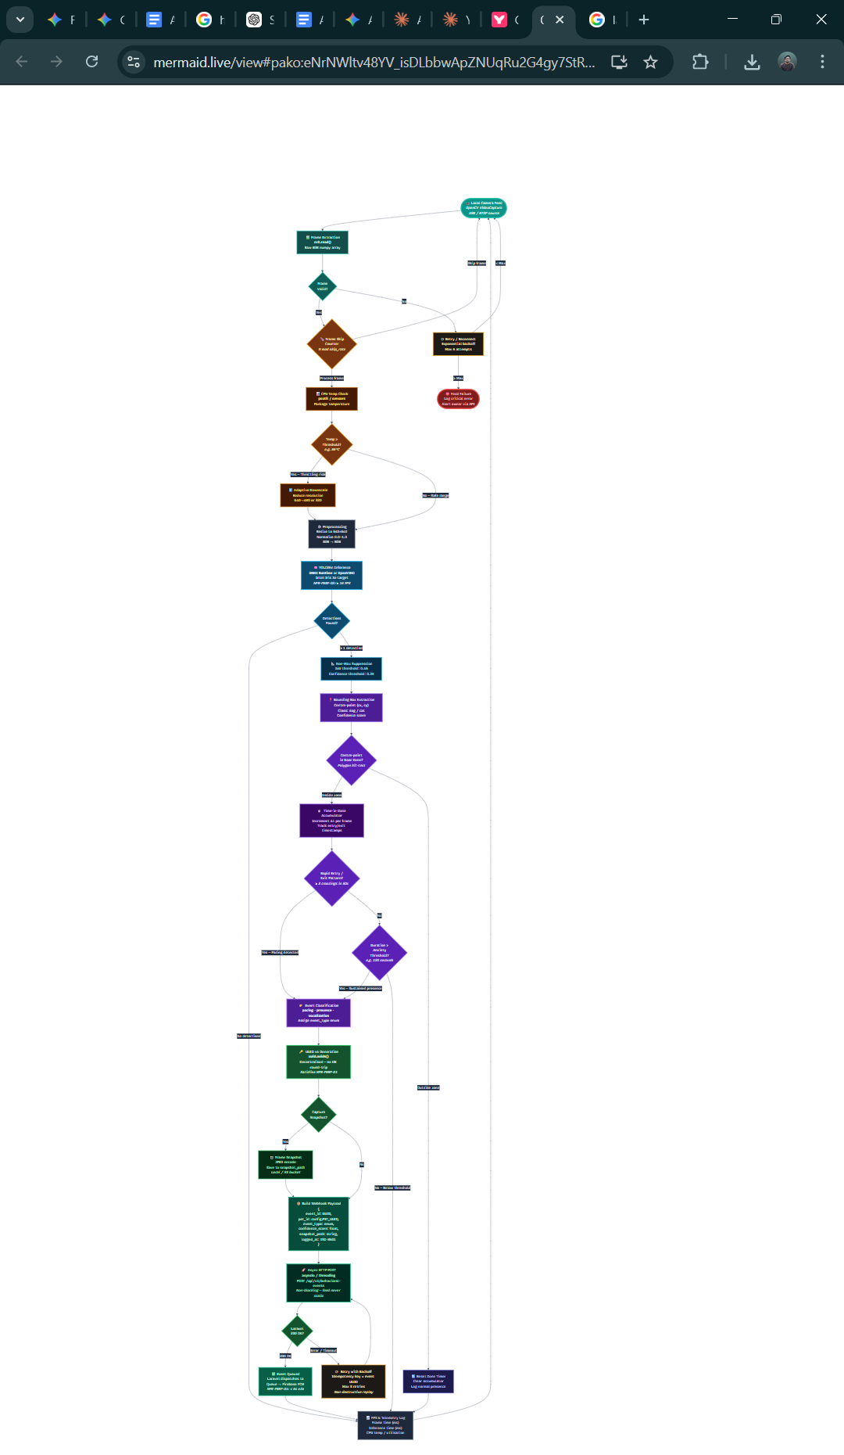

3.4 User experience design
The veterinarian portal adheres strictly to the Next.js App Router paradigm (v16+), defaulting every route segment to a React Server Component (RSC) unless browser-exclusive state binding is strictly required. Under the RSC model, the initial HTML document is rendered on the server with data already resolved against the Laravel API, reducing Time-to-First-Byte and eliminating the hydration delays characteristic of legacy Single Page Applications. The interactive primitives—such as the predictive weight-trajectory visualisations and the JWT-decode handler—are declared as discrete Client Components. The styling layer is constructed exclusively through a CSS-first Tailwind CSS v4+ configuration via a single @import "tailwindcss"; directive. By omitting legacy JavaScript configuration objects, accumulated technical debt is eliminated and incremental build times under the Turbopack compiler are compressed, facilitating an interface-driven development workflow.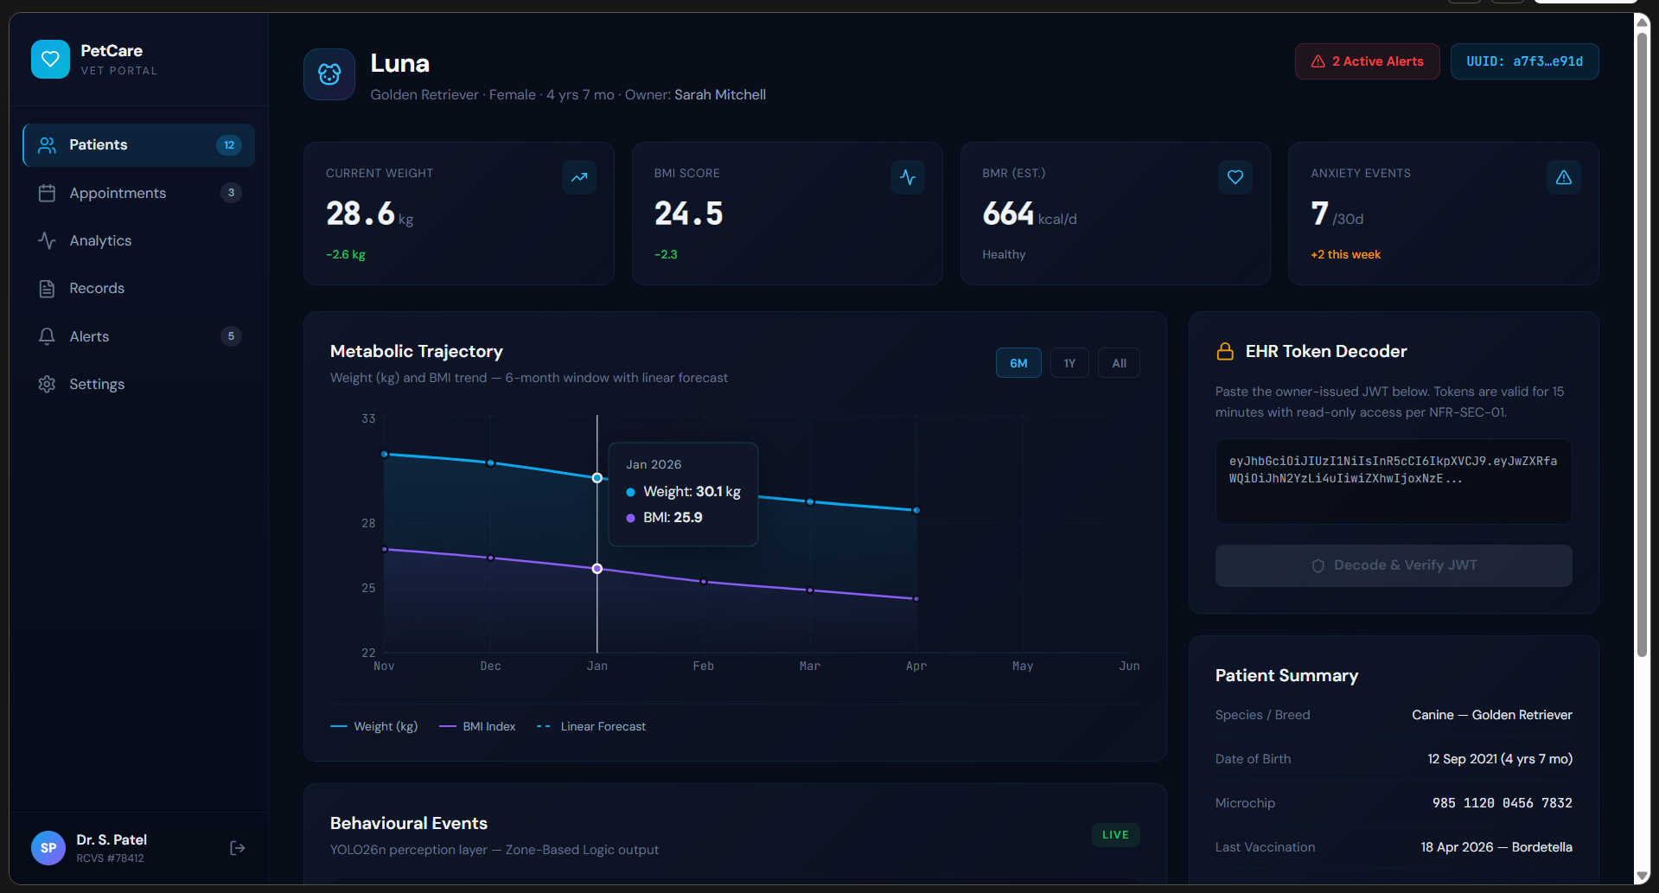
Figure 3: User Interface Wireframes demonstrating the Next.js Veterinarian Portal and the React Native Mobile Application.
The React Native mobile application is engineered under a deliberate dual-environment validation methodology to decouple layout iteration from hardware-bound capability testing. Initial component composition, navigation state, and responsive layout iteration are conducted against the Android Studio emulator hosted on the primary development machine, a Lenovo ThinkBook, which affords rapid hot-reload cycles, scriptable device profiles, and reproducible screen-density regression testing without physical handset tethering. Capabilities that are either unavailable or unreliably emulated — notably Mapbox geospatial routing against live GPS coordinates and Firebase Cloud Messaging push delivery through the Google Play Services runtime — are subsequently validated on physical hardware via the Expo Go client running on the project's reference device, a Redmi Note 10 Pro Max. This separation isolates presentation-layer defects, which are cheaper to diagnose in the controlled emulator environment, from integration defects that arise only under authentic radio, sensor, and notification conditions. The owner-facing interface that is exercised through both environments is deliberately sparse, prioritising the two safety-critical workflows identified in Section 3.1: receipt of behavioural alerts and navigation to emergency veterinary care. When the Python perception service detects a separation-anxiety pattern under the Zone-Based Logic heuristic and dispatches its webhook, the resulting Firebase Cloud Messaging payload surfaces on the device as a categorised push notification carrying the pet identifier, the inferred event type, and a deep-link target. Tapping the notification opens the Behavioural Events screen directly, bypassing intermediate navigation. The alert banner itself uses a high-contrast colour treatment and persistent placement at the top of the event log, ensuring the incident remains visually salient hours after the original push. The Smart Triage workflow is rendered through an embedded Mapbox view displaying the device's live GPS position alongside proximate 24/7 emergency clinics filtered server-side via the is_emergency_24_7 predicate; the nearest candidate is highlighted with a distinct marker, and a single action invokes turn-by-turn routing.
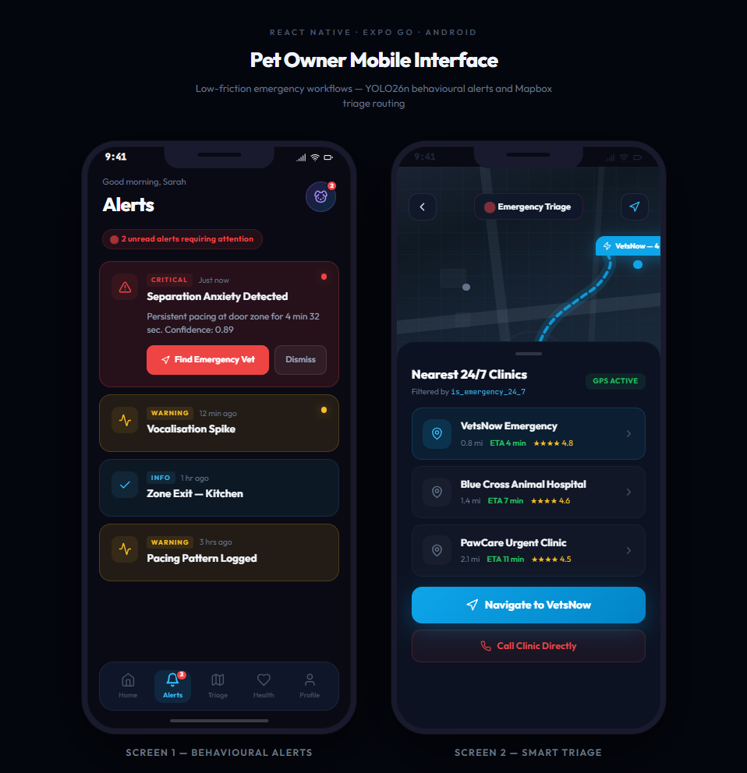
Figure 4: User Interface Wireframes: React Native Owner Application — Behavioural Alerts and Smart Triage screens

4. Planning

4.1 Methodology
The project adopts an Agile methodology operationalised through the Scrum framework, structured as six two-week sprints spanning the implementation window between the AT2 submission and the AT3 software demonstration. Scrum is selected in preference to a linear waterfall model on two defensible grounds. First, the four-tier microservice architecture defined in Section 3 exhibits genuine inter-service uncertainty — the behaviour of the Python perception layer under sustained CPU inference, the latency profile of the Laravel webhook ingestion path, and the hydration characteristics of the Next.js App Router under real data volumes cannot be fully specified in advance and therefore require empirical, iterative refinement. Second, Scrum's sprint cadence aligns naturally with the BCS accreditation expectation of continuous reflective practice, affording a formal retrospective at each sprint boundary that will subsequently evidence the critical self-evaluation component of Learning Outcome 3. Each sprint concludes with a runnable increment across all three repositories, ensuring that integration defects surface early rather than accumulating toward the submission deadline.
Version control is centralised under Git with remotes hosted on GitHub, configured as three discrete repositories: the Python perception service, the Laravel API, and a frontend monorepo housing both the Next.js portal and the React Native client. A trunk-based branching strategy is adopted: feature branches are short-lived, rebased against main prior to merge, and integrated exclusively through pull requests subject to a self-review checklist encompassing PSR-12 conformance for PHP, PEP 8 conformance for Python, and strict TypeScript and React conventions for the frontend tier. Inter-service contract changes are coordinated through an API specification committed to the Laravel repository and consumed as the single source of truth by the downstream clients, materially reducing the surface area over which merge conflicts and contract drift can accrue across the microservice boundary.
The sprint backlog is administered through a visual kanban tracker — Trello is the preferred tool on grounds of zero-cost access and low administrative overhead, with Jira retained as a contingency should finer-grained reporting become necessary — and is structured under the columns Backlog, Sprint, In Progress, Review, and Done. Backlog items are authored as user stories with explicit acceptance criteria mapped back to the FR, NFR, and risk identifiers committed in Section 3, thereby preserving bidirectional traceability between requirements, implementation tickets, and the verification evidence ultimately presented in AT4. The visual board format is a deliberate methodological fit with the interface-driven development workflow declared for the Next.js portal and React Native client: the same visual-first epistemology that governs the user-experience design governs the management of the work that produces it.

4.2 Initial plans
Sprint 1 establishes the Laravel schema, Sanctum authentication, and continuous-integration pipelines. Sprints 2–3 deliver the core RESTful endpoints and the Python perception service under ONNX export. Sprints 4–5 deliver the Next.js dashboard and the React Native client with Firebase and Mapbox integrations. Sprint 6 is reserved exclusively for verification, validation, and AT3 preparation. This rigour directly discharges all four COM668 learning outcomes — synthesis, needs and risk management, methodological integration, and professional communication — by the AT4 submission.
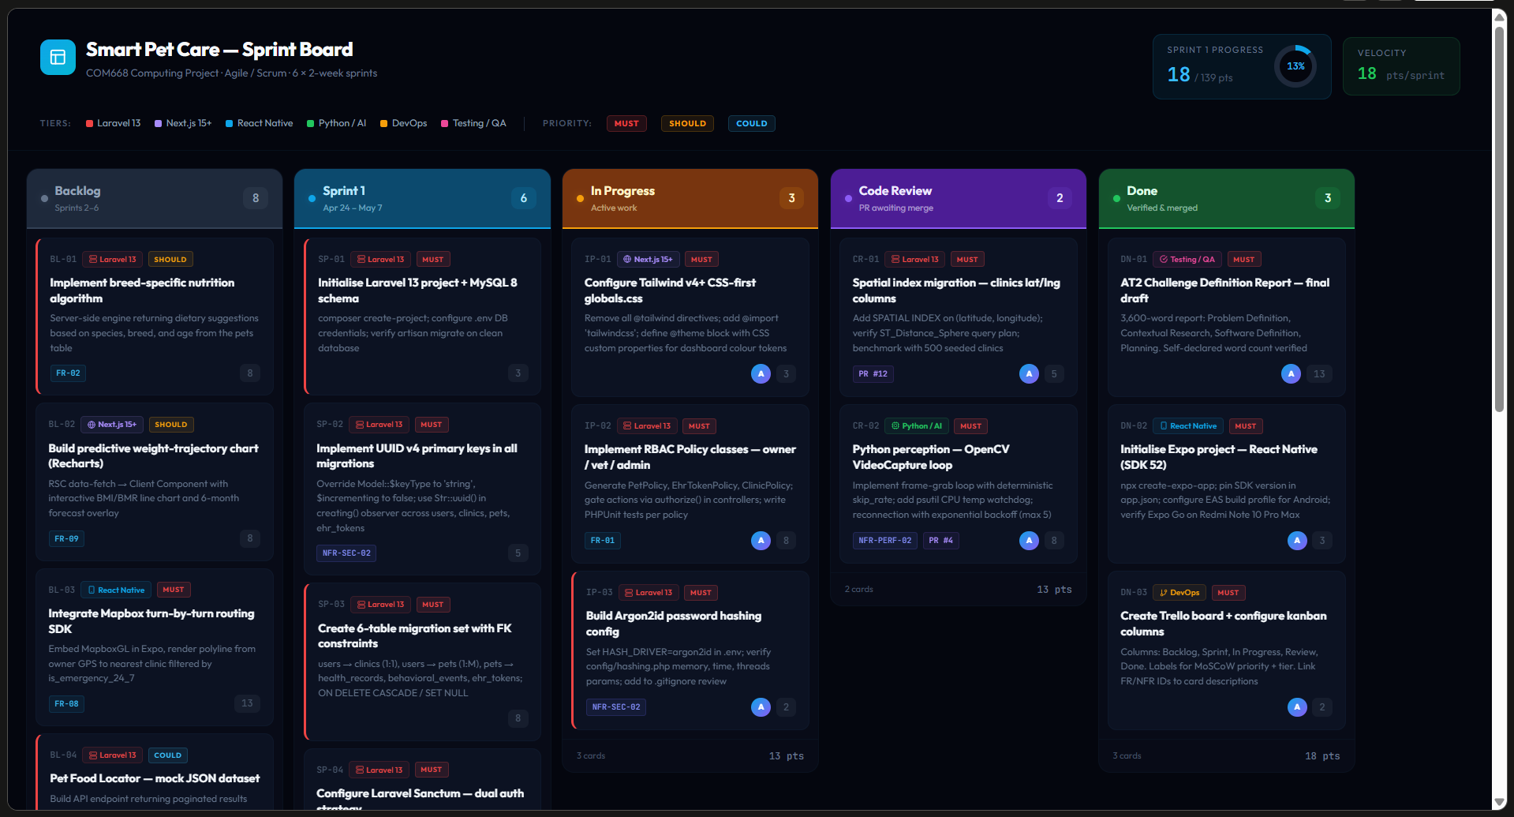
Figure 5: Agile Sprint Backlog and task progression managed via a visual Kanban board.

References
Chamorro, D. and Benítez, D. (2025) 'Animal Tracking System Using Image Processing for Intrusion Detection and Tracking in Human Settlements', International Journal for Multidisciplinary Research, 7(3).
Chappidi, J. and Sundaram, D.M. (2024) 'Novel Animal Detection System: Cascaded YOLOv8 with Adaptive Preprocessing and Feature Extraction', IEEE Access, pp. 1–1.
German, A.J. (2006) 'The growing problem of obesity in dogs and cats', The Journal of Nutrition, 136(7), pp. 1940S–1946S.
Purnama, H. and Sudewa, I.P.B.H. (2026) 'Access Control Development Within the Framework of an IOTA-Based Electronic Medical Record Management System', Sensors, 26(5), p. 1422.
Rahman, M.A., Giordano, S. and Pagano, M. (2025) 'Smart Wildlife Monitoring: Real-Time Hybrid Tracking Using Kalman Filter and Local Binary Similarity Matching on Edge Network', Computers, 14(8), p. 307.
Rajesh, T.H. et al. (2025) 'Smart, Secure and Scalable Cloud-Based Healthcare System', International Journal of Scientific Research in Engineering and Management (IJSREM), 9(2), pp. 1-8. Available at: https://ijsrem.com/ (Accessed: 21 April 2026).
Sargisson, R.J. (2014) 'Canine separation anxiety: strategies for treatment and management', Veterinary Medicine: Research and Reports, 5, pp. 143–151.
UK Pet Food (2024) Obesity Report 2024. Available at: https://www.ukpetfood.org/information-centre/statistics/obesity-report.html (Accessed: 21 April 2026).

